**Bug Bash UI changes**

1. **Professor Teresco's comments**:
2. Pseudocode window should not pop up by default. Should match the algorithm you are visualizing.
3. Add legends. Choices for color schemes. DONE

* Longest edge: Please change to dark brown
* Shortest edge: Please change to dark blue

1. Page title should not really be "Clinched Highway Mapping", better would be "Algorithm Visualization with Map Data". DONE

**Group 1’s comments**:

1. Shaun:

* Please add a directions page. Directions ‘pop window’ would be great!

1. Kalyssa:

* Please change the name of label, “Point Search Viz” to “Start Algorithm Visualization” DONE
* In the Longest/Shortest Edge Search Algorithm, please zoom in and automatically display the Edge on the map, when an edge name is selected in the 2nd table.

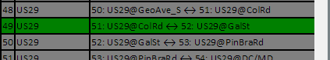

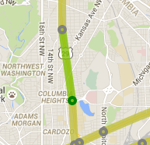

* The contents of the middle toolbar do not fit appropriately on resizing:

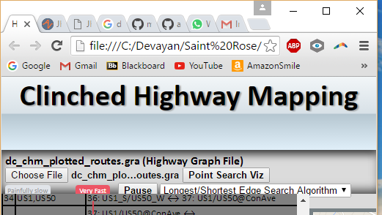

Kalyssa/Victor: Please use ‘Dynamical resizing’ and/or increase the width of the middle toolbar to accommodate the contents correctly.

1. Victor:

* In the Extreme Waypoint Search Algorithm, please zoom in and automatically display the Waypoint co-ordinates on the map, when a waypoint name is selected in the 1st table.

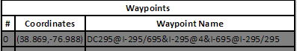

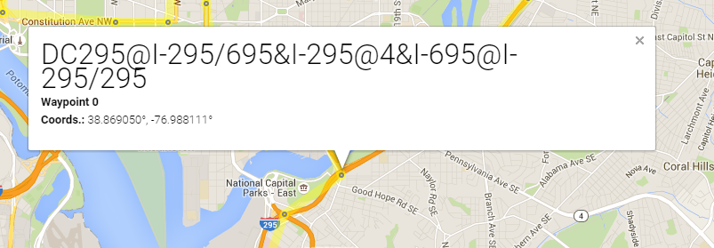

* **Prof Teresco**: Please remove the gray circles around the Waypoints. This is not required in the Longest/Shortest Edge Search Algorithm.

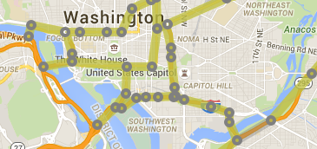

* **Prof Teresco**: On selecting a new algorithm, the table and map should be refreshed.
* **Prof Gero/Kalyssa**’

Kalyssa thought, “Painfully” did not sound appropriate. Prof Gero said that “Pretty Slow should come after Slow”

The order of levels in speed might better be described as ‘Very Slow – Slow – Moderately Slow – Moderately Fast – Fast – Very Fast – Extremely Fast’ instead of ‘Painfully Slow - Slow – Pretty Slow – Medium Speed – Fast – Very Fast – Extremely Fast DONE

1. **Group 3’s comments**:
2. Jigar:

* Please begin middle toolbar from the left-hand side.
* Please add a ‘Speed’ label.
* Please link Prof Teresco’s Clinched Highway Mapping websites to the Algorithm Visualization webpage.